**Centre Name: ACE-HCMC-2-FPT.**

**Address: 590 Cach Mang Thang 8, District 3, Ho Chi Minh City, Viet Nam.**

**ONLINESHOP4DVDS**

**Design Document**

|  |  |  |
| --- | --- | --- |
| **Supervisor:** | Mr. Le Tuan Xuyen | |
| **Semester:** | 3 | |
| **Batch No:** | T1.2303.M0 | |
| **Group No:** | 3 | |
| **Order:** | **Full name** | **Roll No.** |
| 1. | Bùi Trần Nguyên Hưng | Student1462831 |
| 2. | Trương Nguyễn Quang Huy | Student1468180 |
| 3. | Nguyễn Anh Khoa | Student1459131 |
| 4. | Bùi Thị Nhung | Student1459130 |
| 5. | Vũ Minh Tuấn | Student1459120 |

* **This is to certify that**

**Mr.** Bùi Trần Nguyên Hưng

**Mr.** Trương Nguyễn Quang Huy

**Mr.** Nguyễn Anh Khoa

**Mr.** Vũ Minh Tuấn

**Ms.** Bùi Thị Nhung

**have successfully designed & developed:**

eProject:ONLINESHOP4DVDS

* **Submitted by:**

Mr. Le Tuan Xuyen

**Date of issue:** 02/08/2024

**Authorized Signature:**

**Table of Contents**

REVIEW 1 4

I. Introduction 5

II. Synopsis: 5

III. Problem Definition: 6

IV. Customer's Requirement Specifications 7

1. Home Page: 7

a. Header – All Page for client will extend the header: 7

b. Body: 7

c. Footer – All Page for client will extend the Footer: 8

2. Login(Register) Page: 8

3. Game/Album/Movie Page: 8

4. Contest Page: 8

5. About us/Contact Page: 8

6. Customer’ Page: 8

7. Wishlist Page: 8

8. Feedback Page: 8

9. Dashboard Page: 8

a. Manage Categories : 9

b. Manage Artists: 9

c. Manage Albums: 9

d. Manage songs, games, movies: 9

e. Manage Users: 9

f. Manage Feedback: 9

g. Manage Suppliers: 9

h. Manage Producers: 9

i. Manager Permissions: 10

j. Manage Products: 10

k. Manage Purchasing Invoices: 10

l. Manage Orders: 10

m. Manage Reports: 10

n. Manage Advertising: 10

o. Manage News: 10

p. Manage Administrators: 10

q. Manage Album Reviews: 11

r. Manage Promotion: 11

s. The registered user: 11

t. The guest user who is not the member of site: 11

10. Non-functional Requirement Specifications 12

V. System Requirement Specifications 13

1. Server requirements: 13

a. Hardware: 13

b. Software: 13

2. Development Software: 13

3. Technology: 14

1. TASK SHEET REVIEW 1 15

REVIEW 2 16

I. Architecture & Design of the Project 17

1. Presentation 17

2. Business Logic 17

3. Data Access 17

II. Algorithms – Data Flowchart 18

1. Symbol generates: 18

2. Main data flowchart for us 19

3. Login process (For admins and members) 20

4. Logout process (For admins and members) 20

III. Use Case Diagram 20

IV. Entity – Relationship Diagrams 21

TASK SHEET REVIEW 2 22

REVIEW 3 23

I. Site map 24

1. Client site map 24

2. Dashboard site map 25

II. Graphical User Interface (GUI) design 26

1. Client GUI 26

a. Home page (Index) 27

b. Album/Game/Music 30

c. News 34

d. About Us 38

e. Support (Feedback) 39

2. Dashboard GUI 43

a. Login & Register 44

b. Authorized 50

III. Dashboard 51

1. User management 51

2. Customer management 51

# 

# REVIEW 1

## Introduction

We'd like to thank you everyone on behalf of Group 3 for your efforts and support in bringing this eProject to a successful conclusion. We received a lot of assistance from our teacher, Mr. Le Tuan Xuyen, starting on the first day of Sem 3 at FPT Aptech. He has led us in this eProject with his zeal and discipline, and it is thanks to him that we will be able to complete this project. Therefore, Mr. Xuyen, let us say once more how much we appreciate your commitment and leadership.

In addition, we want to thank the entire group 3 team for their dedication to finishing this project over the course of four weeks.

Last but not least, we would like to express our gratitude to the Aptech eProject team for giving us the chance to put what we had learned into practice and obtain practical experience that would be valuable for our future careers.

## Synopsis:

The Objective of this program we aim is to give a sample project to work on real life projects. These applications help us build a larger, more robust application.

The objective is not only to teach us C Sharp, .Net, ReactJS but also to provide us with a real life scenario and help us create basic applications using the tools. We can enhance our skills and value with the project.

Music, Game, Movie is an important part of our life. Nowadays, listening to music online is hobby of most modern people. So you need to build website where users will get relevant information about the latest music, game, movie releases in the market.

This website has web pages that give information about the new releases in the field of music, game, and movie in the National market.

It is very essential for us to have a clear understanding of the subject. We think we should go through the project and solve the assignments as per requirements given.

## Problem Definition:

Music, Game, Movie is an important part of our life. Nowadays, listening to music online is hobby of most modern people. So you need to build website where users will get relevant information about the latest music, game, movie releases in the market.

The site will allow users to view all kinds of music, game, movie - includes National and International, listen to some music, see trailers game, movie, and download them for free some but not full, vote for an album, game, movie and send feedback about the site, etc. In addition, this website also provides a forum that users could discuss. The website has search and browse functions too.

When users need to know information about recent releases of music, game, movie they can open this website to see or search some information, and naturally, they can buy some DVDs if they want.

If users want to know information regarding music, game, movie or they wish to buy a new DVDs, they need not visit a shop at all. Instead of this, they can just open the website to refer to information about music displayed on the web pages and place an order. Finally, what’s thing that we want customers: come to see, and buy new releases albums.

## Customer's Requirement Specifications

A web-site incorporating all the information about the ONLINESHOP4DVDS services is required with following functionality

There should be a menu categorizing the various aspects of the ONLINESHOP4DVDS. The detailed menu options are as mentioned below.

### Home Page:

#### Header – All Page for client will extend the header:

* There is the 1st navbar including the following:
* Logo on the left side
* A search bar is next to the Logo
* A cart and account login are on the right side
* There will be a 2nd navbar including 5 Tabs:
* Home
* Album
* Movie
* Game
* News
* About
* Support

#### Body:

* First section is a Slider, will the current seasonal promotion.
* Second section is a 4 respective areas showing promotion or preorder for products of each categories.
* Third section will show 3 areas for each main categories (Music, Game, Movie)
* Section Announcements will show the winner of the contest
* Last section is a slider showing all featured brands/artists.

#### Footer – All Page for client will extend the Footer:

* Show all information of owner ( owner email, all services, Quick links)
* At the end of the footer, will have a bar, on the left will show Copyright info, on the right will show Developed info.

### Login(Register) Page:

* This page will show the form to register or login.

### Game/Album/Movie Page:

* In this page, will has sections about type of game
* Each product detail page will show information on the specific game such as Price, promotion (if any), description, trailer, etc…
* Review: will show reviews from registered user who bought the product.

### Contest Page:

* It should provide the form available to fill so users can participate in a contest.

### About us/Contact Page:

* This page will display the information on the store and contact information.

### Customer’ Page:

* This page will display all the information of a customer account.
* User can edit, remove, or view their own transaction history.

### Wishlist Page:

* The user can view their personal wishlist. Update their favorite products in the list.

### Feedback Page:

* The visitor can send email to feedback about the views related to the site.

### Dashboard Page:

In this page, admins can manage these following functions:

#### Manage Categories :

This function contains view categories, adding a new category, deleting, editing, search.

#### Manage Artists:

* Artist is a composer or a singer or both.
* This function contains view artists, adding a new artist, deleting, editing, search.

#### Manage Albums:

* This function contains view albums, adding a new album, deleting, editing, search.

#### Manage songs, games, movies:

* This function contains view, adding a new, deleting, editing, search.

#### Manage Users:

* User can be a guest or a member or a customer.
* A user hasn’t registered at website is a Guest.
* A user has already registered at website is a Member.
* Member is called a Customer if he buys album from the website or he had an account at Website.
* This function contains view users, adding a new user, deleting, editing, search and recovery user.

#### Manage Feedback:

* This function contains view, deleting, reply and search feedback of users.

#### Manage Suppliers:

* Supplier is company which supplies music’s discs for website.
* This function contains view suppliers, adding a new supplier, deleting, editing, search and recovery supplier.

#### Manage Producers:

* Producer is a company which publishes.
* This function contains view producers, adding a new producer, deleting, editing, search and recovery producer.

#### Manager Permissions:

* Permission of website is divided into many module functions. Each module function has own functions such as view, adding, deleting and editing.
* This function contains view permissions of an administrator, assigning permissions, unassigned permissions and editing permission.

#### Manage Products:

* A product is an album which is sold on the website.
* This function contains view products, adding a new product, deleting, editing, search.

#### Manage Purchasing Invoices:

* This function contains view purchasing invoices, adding a new purchasing invoice, deleting, editing, search.

#### Manage Orders:

* This function contains view orders, deleting, editing, search.

#### Manage Reports:

* This function helps admin can view reports.

#### Manage Advertising:

* This function contains changing banner of website, and changing all ads of website. The Ads can be placed in any position.

#### Manage News:

* This function contains view, adding, deleting, editing, search and recovery news of music, game, movie. Include National and International news.

#### Manage Administrators:

* Admin manages website and manage other administrators.
* This function contains view administrators, adding a new administrator, deleting, editing, search and recovery administrator.

#### Manage Album Reviews:

* Admin manages all reviews about album of users.
* This function contains adding, deleting, editing and search album reviews.

#### Manage Promotion:

* Admin manages promotion on website.
* This function contains view all promotions and adding new promotion.

#### The registered user:

* Member is a user who registered at website. Signing in the website, a Member can use these below functions:
* All functions of Guest.
* Download music, trailer movie, or movie game.
* Buy DVD on website:
* Write the review about album, movie, game or rating.
* Change profile (view profile, edit profile, change password, cancel account)
* Send feedback.
* Member can manage his Website Account (such as Check Balance, View Transactions Log).
* Member can manage history orders (such as view history orders …).

#### The guest user who is not the member of site:

* Guest is a user who doesn’t register at website. He can use these below functions:
* Read news about music, game, movie on website.
* Browse or search information about an artist, an album, a song or a lyric, or see trailer game, movie or information content about them.
* Listen to free trailer movie, and some music online (but not full DVD)
* Join the forum of website.

### Non-functional Requirement Specifications

* + Good using Interface and Experience
  + Clean code
  + Try hard to improve the performance
  + Try limit bugs on this website

## System Requirement Specifications

The Guest accessing the website for the first time can register right away or just search for a product but lack service. When they want to actually buy a product and pay for it, they need to register to become a customer then all of the service will be available.

### Server requirements:

#### Hardware:

|  |  |
| --- | --- |
| Component | Requirement |
| CPU | Processor type:  Pentium III-compatible processor or faster  Processor speed:  Recommended: 1.0 GHz or faster |
| OS | All OS(Windows ,Linux ,Android ,Mac OS …) |
| Memory (RAM) | RAM:  Minimum: 1 GB  Recommended: 2 GB or more  Maximum: Operating system maximum |
| Hard Drive | Free space:  Minimum: 10 MB |

#### Software:

|  |  |
| --- | --- |
| Component | Requirement |
| Web Browser | IE 8.0 , Firefox 3.0,Chrome or Higher….. |

### Development Software:

Microsoft SQL server Management Studio

Microsoft Visual Studio 2022

### Technology:

ASP.Net Core 8.0

Entity Framework Core 8.0

## TASK SHEET REVIEW 1

|  |  |  |  |  |  |  |  |
| --- | --- | --- | --- | --- | --- | --- | --- |
| **Project Ref. No.:**  **eP/Advertisement** **Portal Management** **System/01** | | **Project Title:** | **Activity Plan** **Prepared** **By:** | **Date of Preparation of Activity Plan:** | | | |
| **Sr.No.** | **Task** | **Actual Start** **Date** | **Actual** **Days** | **Team** **Mate** **Names** | **Status** |
| 1 | Introduction | ONLINESHOP4DVDS | All member | 05/19/2024 | 1 | Nhung | Completed |
| 2 | Problem Definition | 05/19/2024 | 1 | Khoa | Completed |
| 3 | Requirement & Non-functional requirement | 05/19/2024 | 1 | Tuấn & Hưng | Completed |
| 4 | Process Analyst & Task sheet review | 05/19/2024 | 1 | Tuấn & Huy | Completed |

# 

# 

# REVIEW 2

## Architecture & Design of the Project

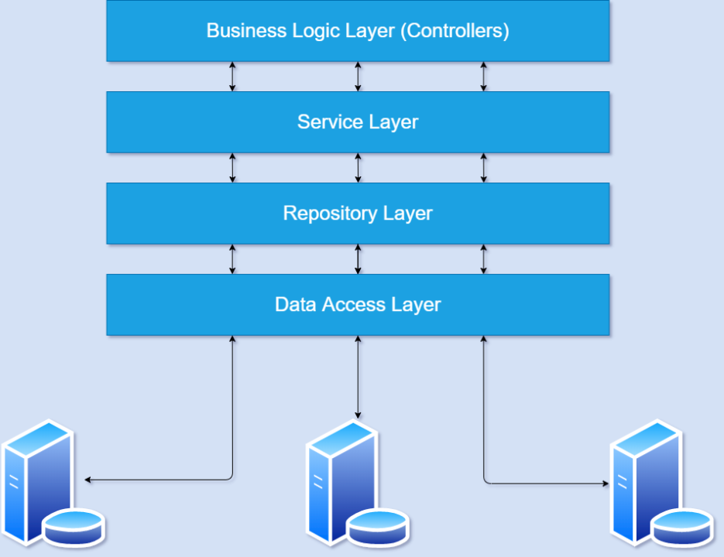

### Presentation

* Exposes interaction capabilities for the end users or applications / systems wanting to interact with it.
* Interacts with the Business Logic layer.
* Can interact with other applications (through their presentation layers).

### Business Logic

* Expresses domain knowledge, to be utilized from the Presentation layer.
* Interacts with the Data Access layer.
* Can interact with other applications (through their presentation layers).

### Data Access

* Acts as a data persistence, to be utilized from Business Logic.
* Can interact with other applications (through their presentation layers).

## Algorithms – Data Flowchart

### Symbol generates:

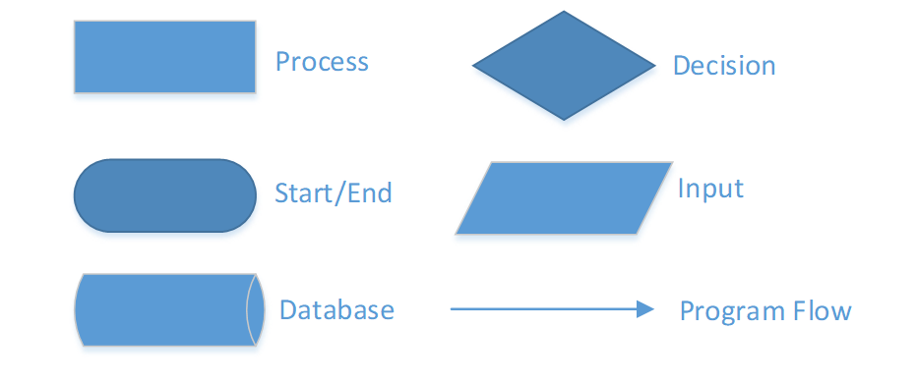

### Main data flowchart for us

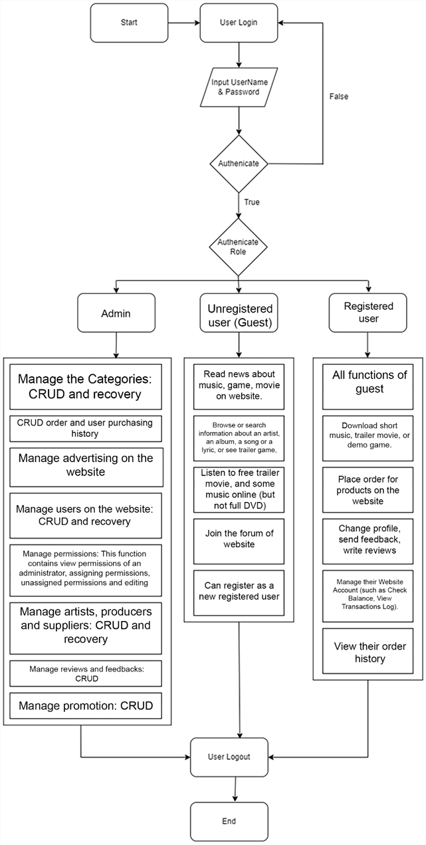

### Login process (For admins and members)

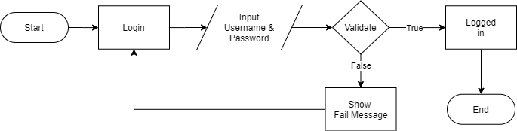

### Logout process (For admins and members)

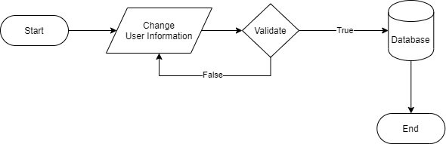\

## Use Case Diagram

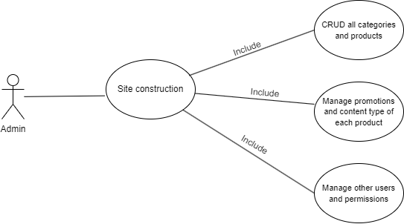 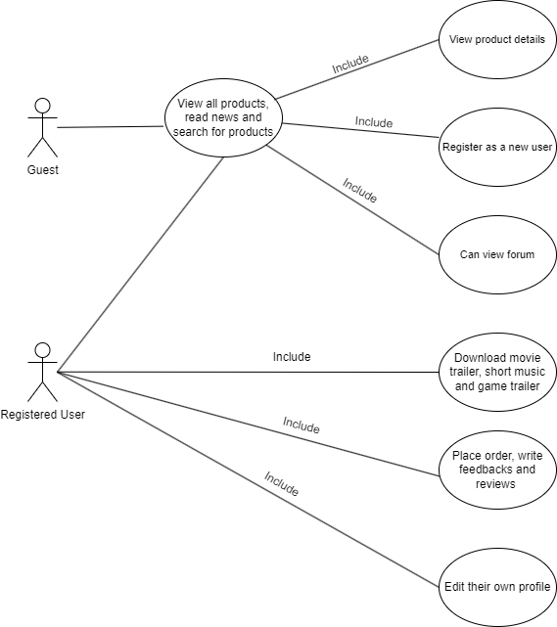

## Entity – Relationship Diagrams

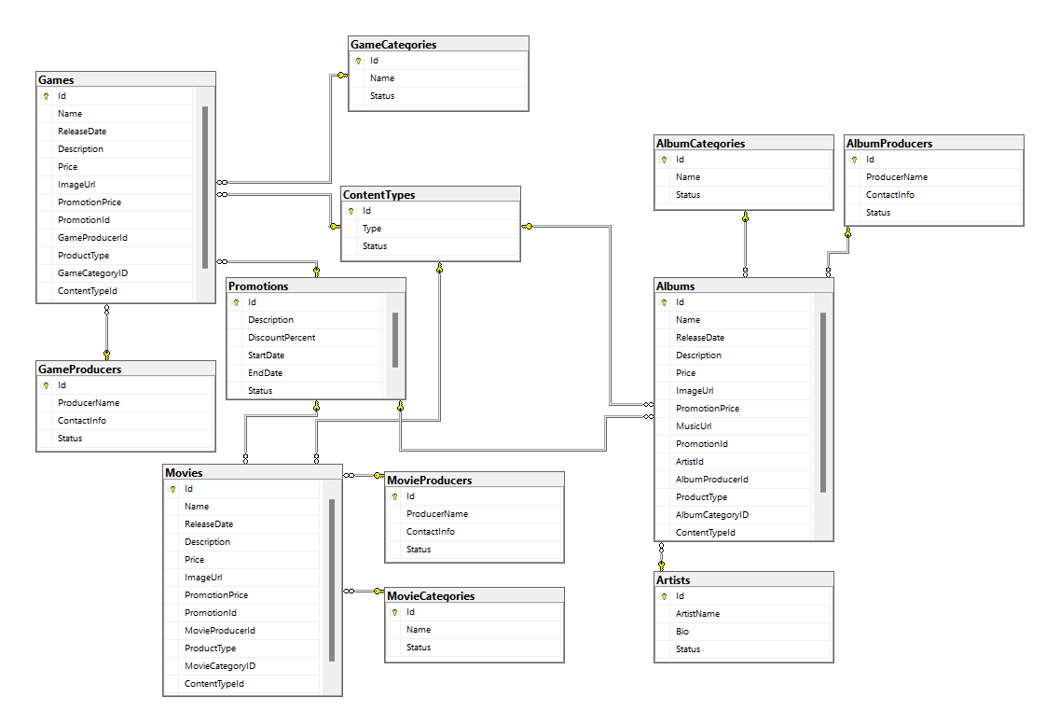

# TASK SHEET REVIEW 2

|  |  |  |  |  |  |  |  |
| --- | --- | --- | --- | --- | --- | --- | --- |
| **Project Ref. No.:**  **eP/Advertisement** **Portal Management** **System/01** | | **Project Title:** | **Activity Plan** **Prepared** **By:** | **Date of Preparation of Activity Plan:** | | | |
| **Sr.No.** | **Task** | **Actual Start** **Date** | **Actual** **Days** | **Team** **Mate** **Names** | **Status** |
| 1 | Architecture & Design of Project | ONLINESHOP4DVDS | All Members | 07/29/2024 | 1 | Tuấn | Completed |
| 2 | Algorithms – Data Flowchart | 07/29/2024 | 1 | Khoa & Huy | Completed |
| 3 | Use Case Diagram & Task sheet review | 07/29/2024 | 1 | Hưng | Completed |
| 4 | Entity-Relationship Diagram | 07/29/2024 | 1 | Tuấn | Completed |

|  |  |
| --- | --- |
| **Date: 07/29/2024** | |
| **Signature of Instructor:**  **Mr. LE TUAN XUYEN** | **Signature of Team Leader:**  **VU MINH TUAN** |

# 

# REVIEW 3

## Site map

### Client site map

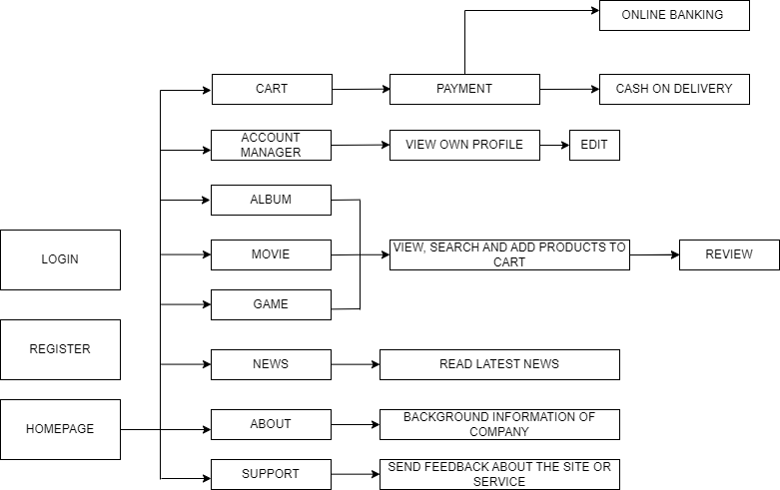

### Dashboard site map

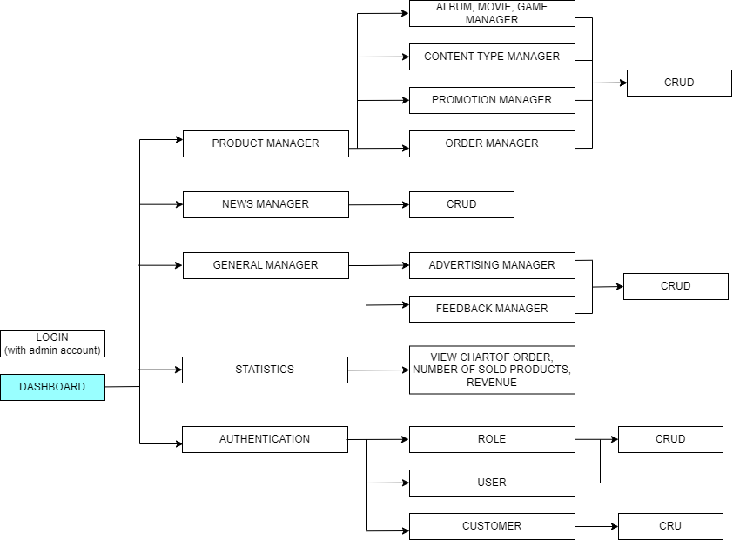

## Graphical User Interface (GUI) design

### Client GUI

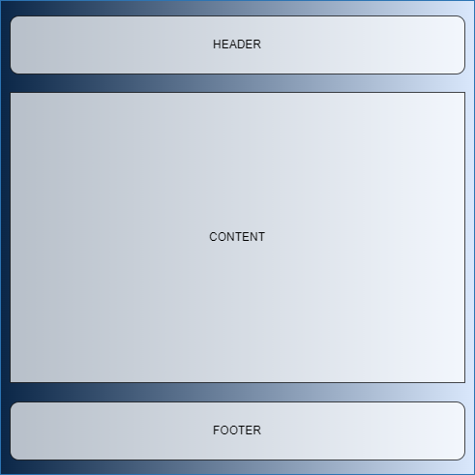

#### Home page (Index)

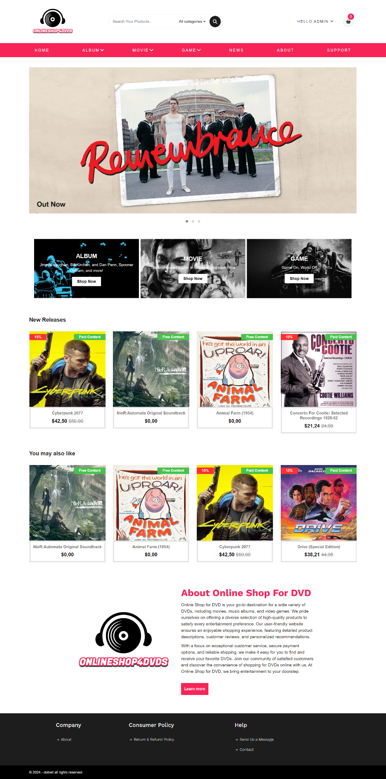

Code:

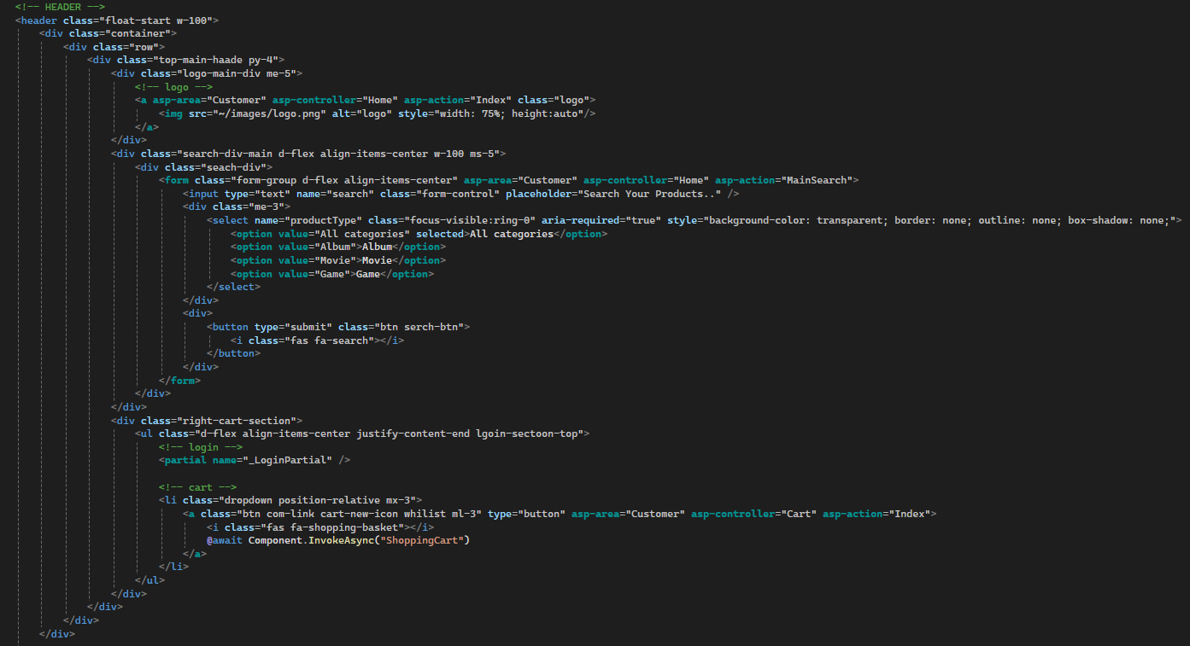

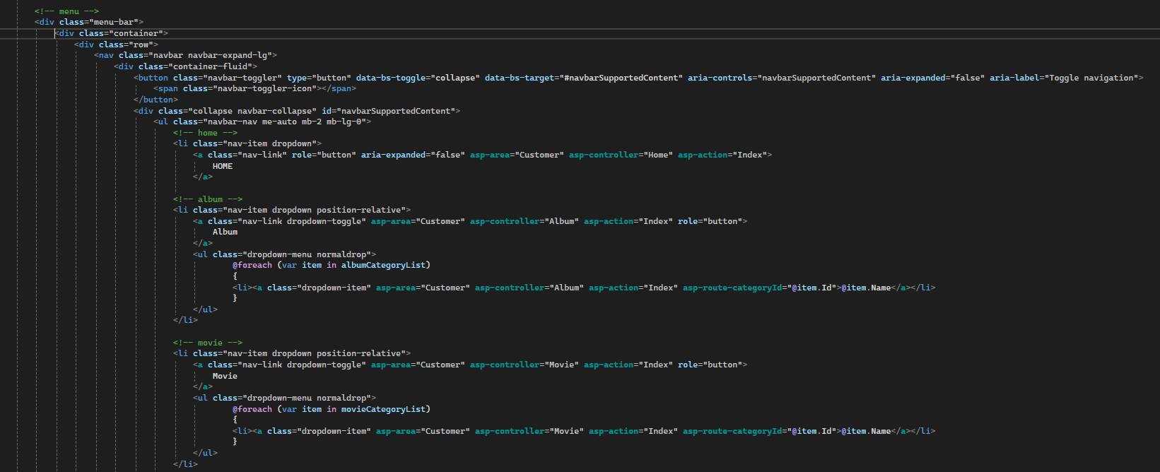

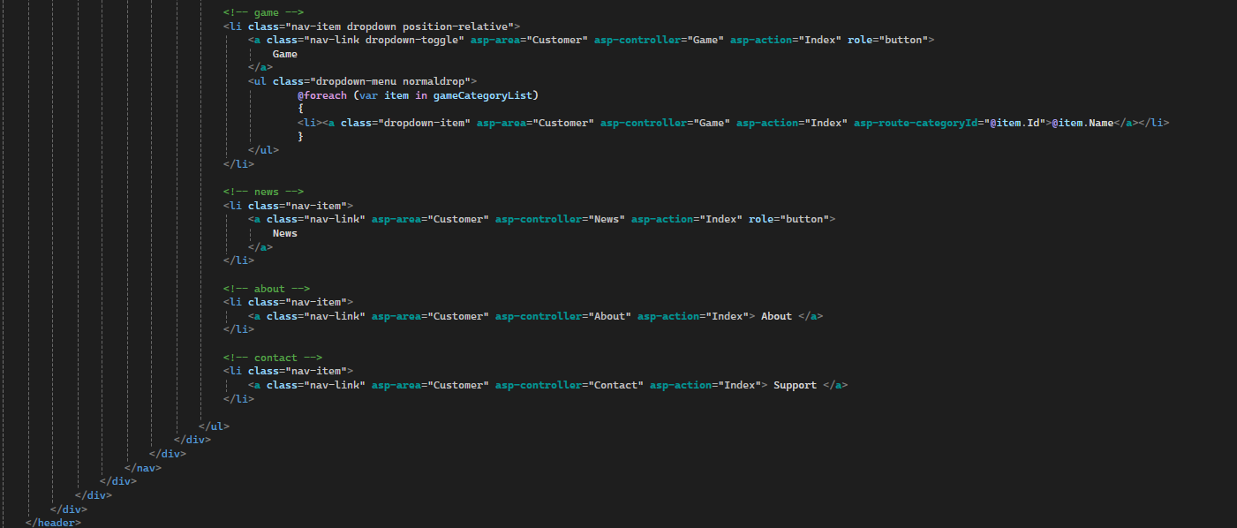

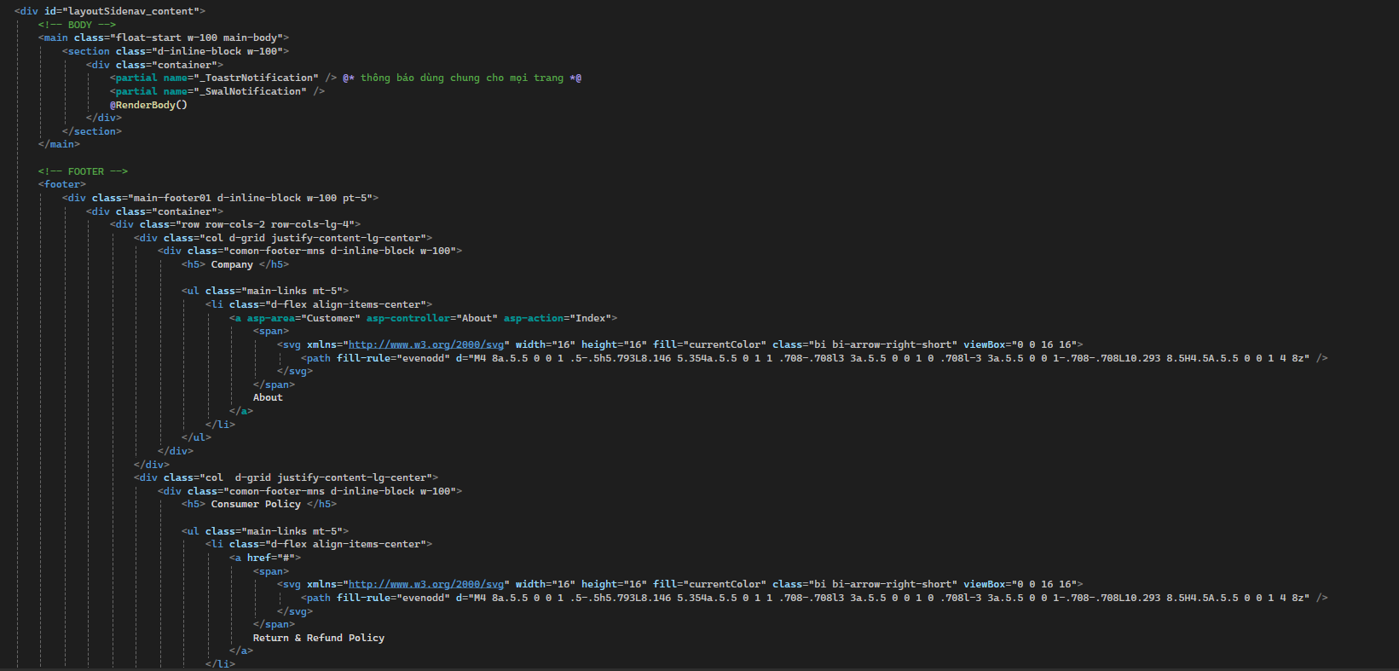

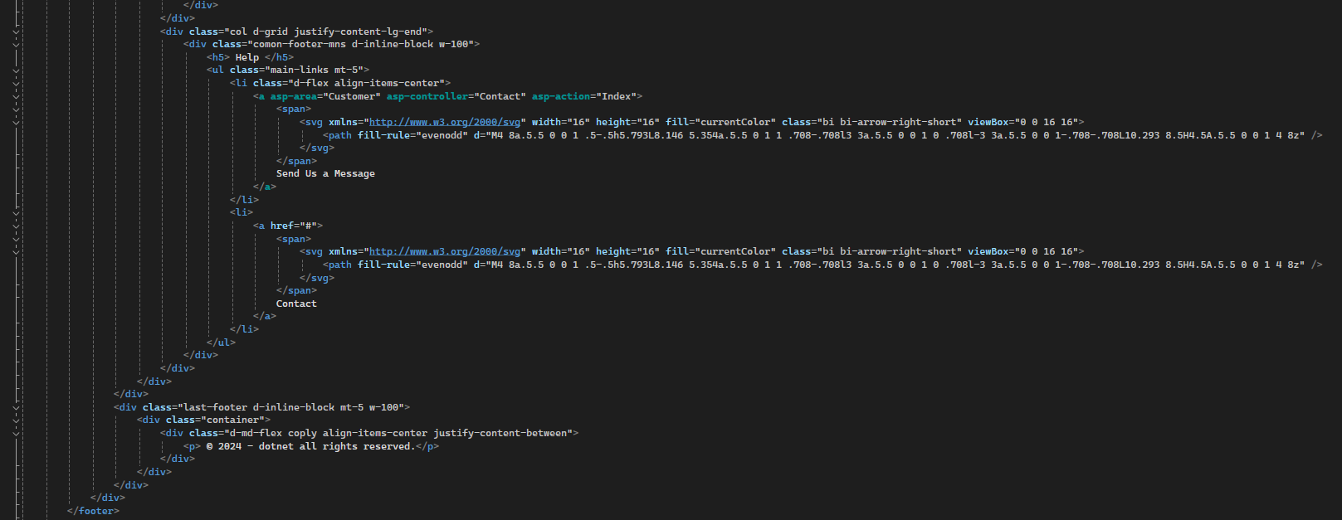

#### Album/Game/Music

We will be using Album as example to show our page and code in the following section.

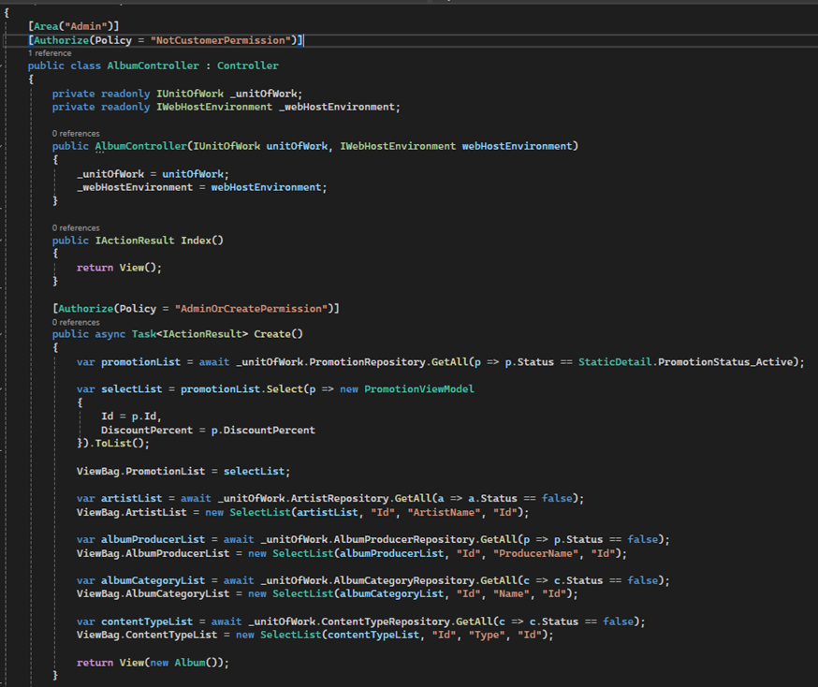

Example Code (in this case we use the Album Controller as example)

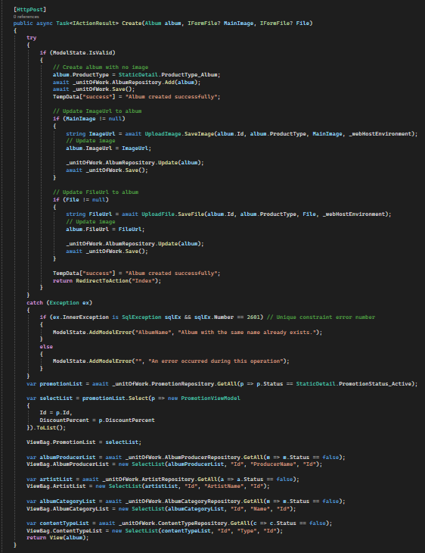

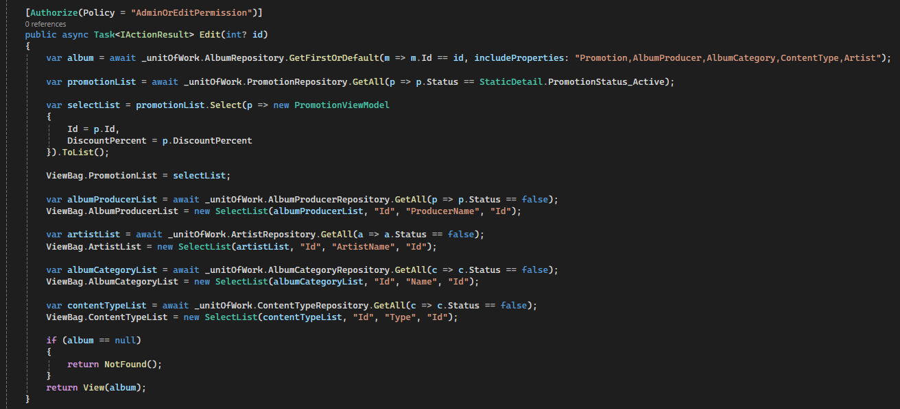

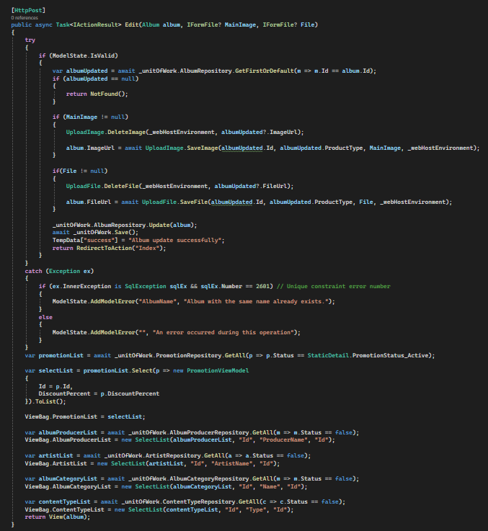

#### News

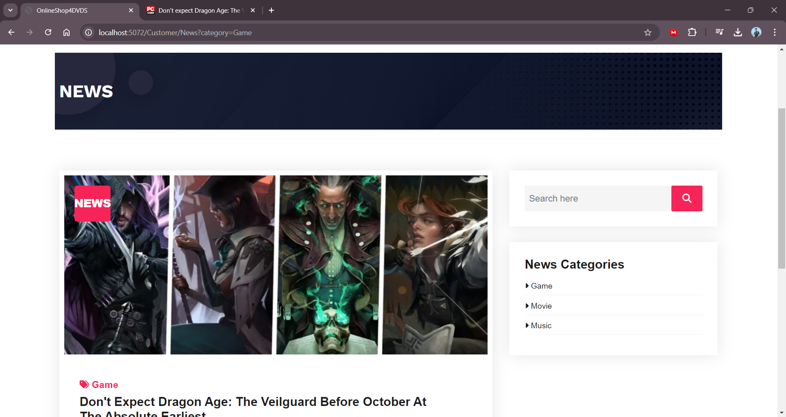

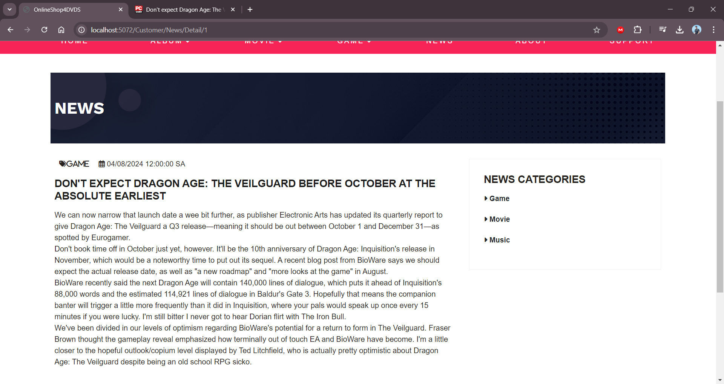

Code:

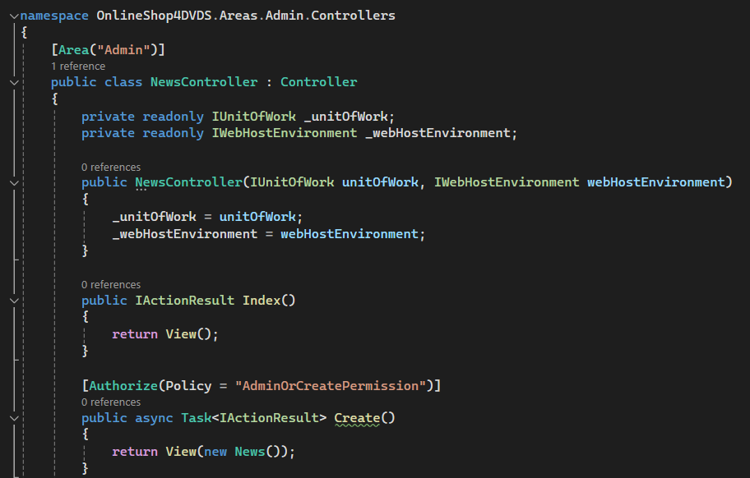

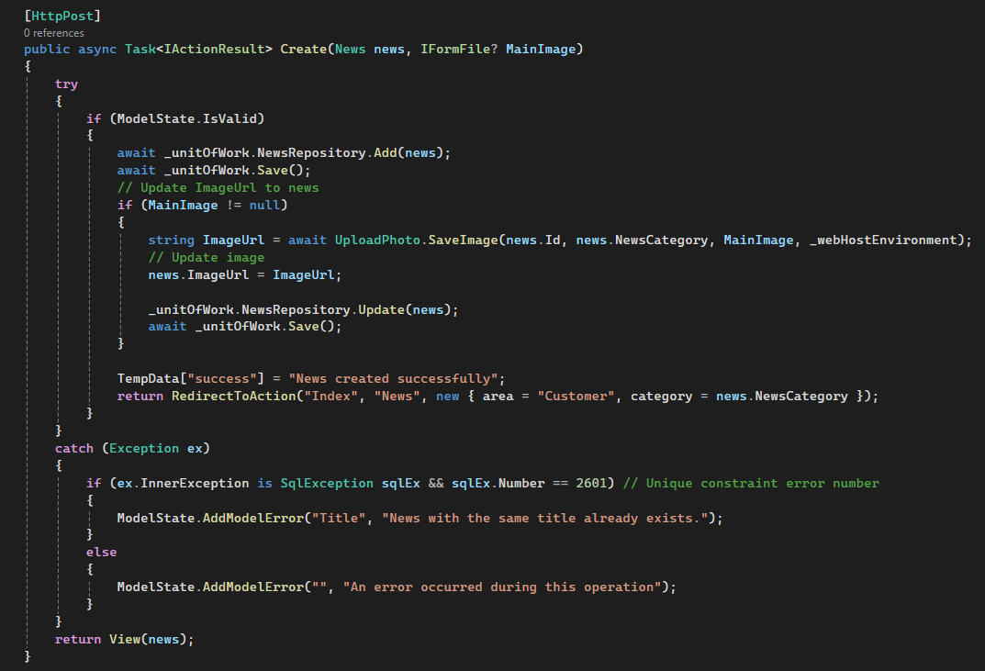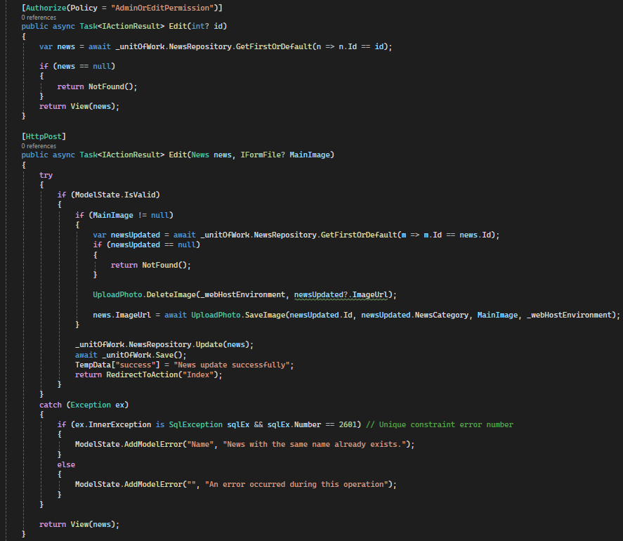

#### About Us

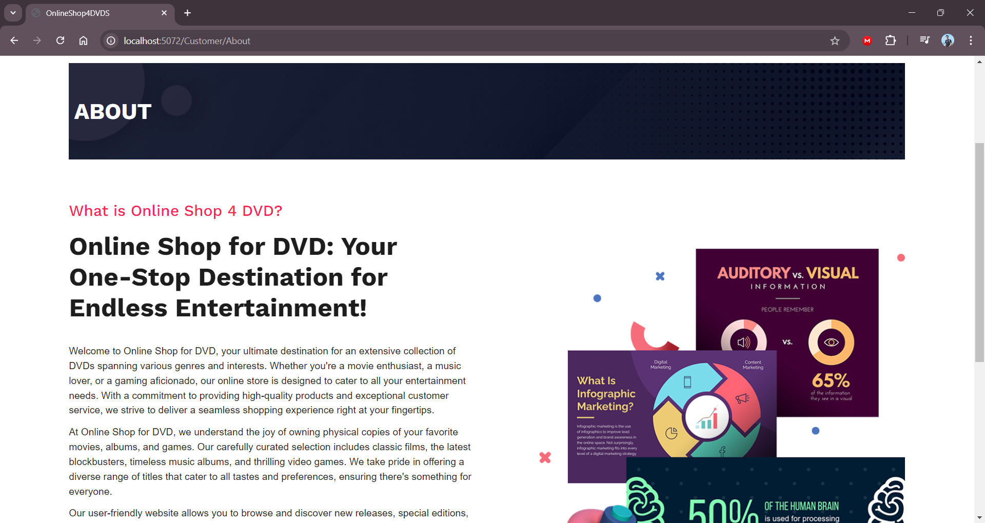

Code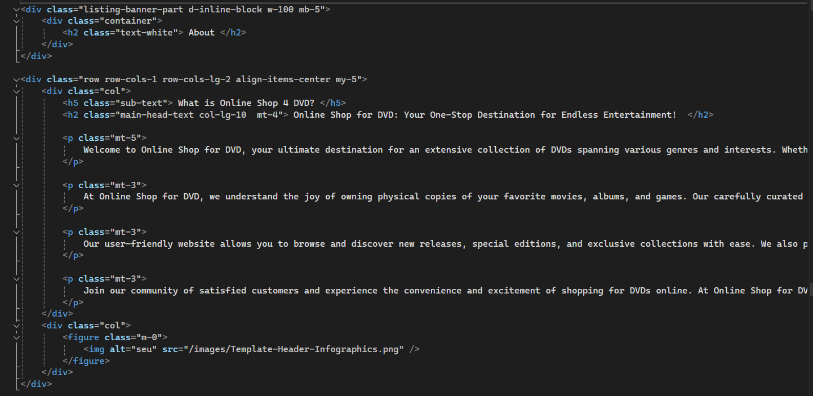

#### Support (Feedback)

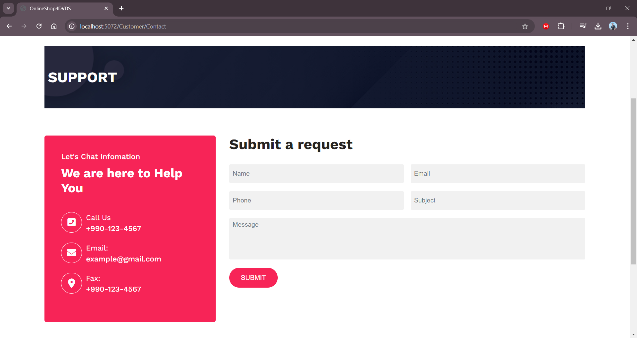

Code:

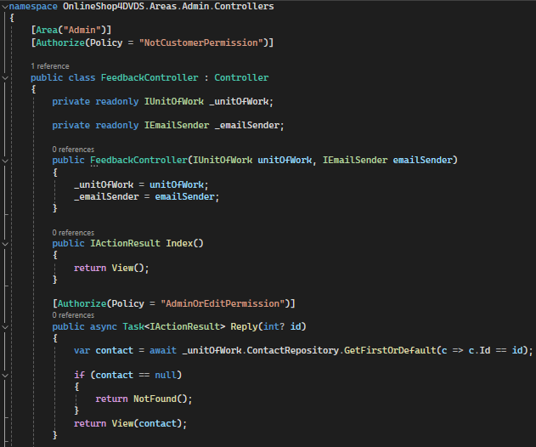

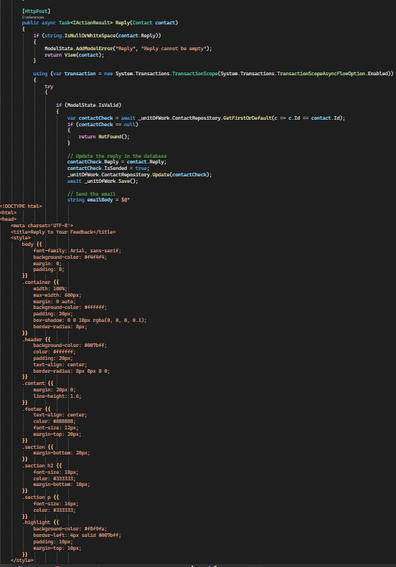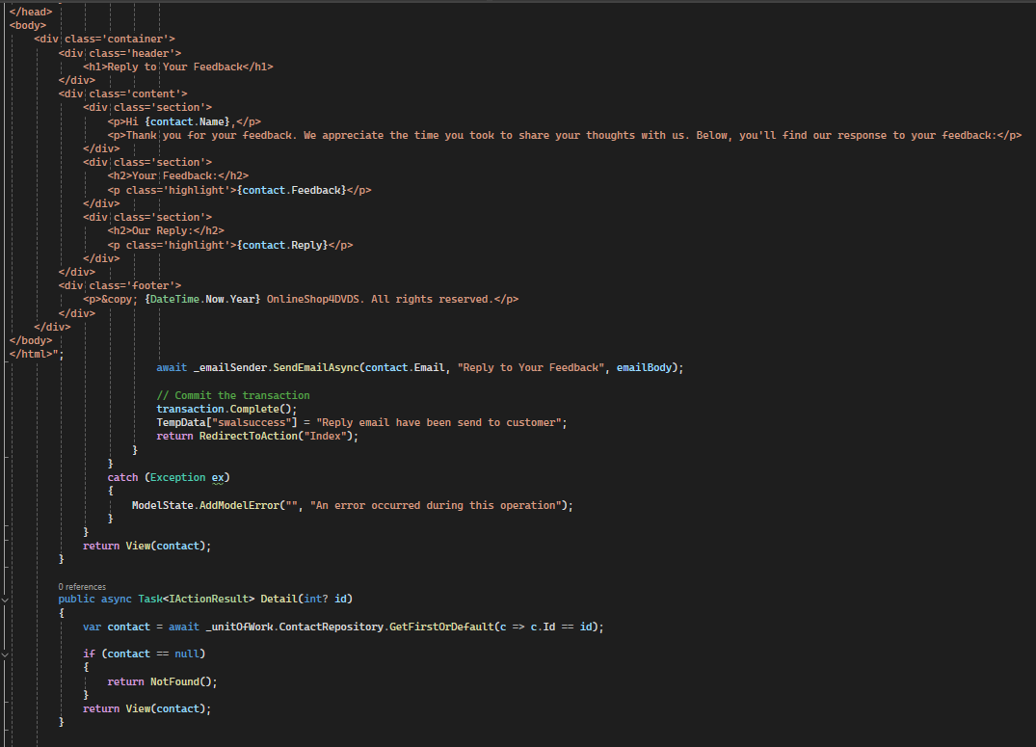

### Dashboard GUI

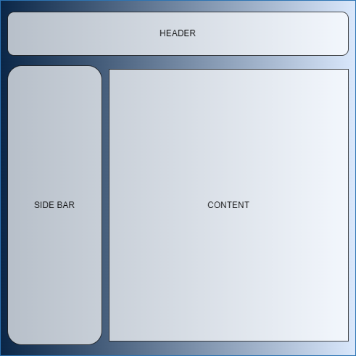

#### Login & Register

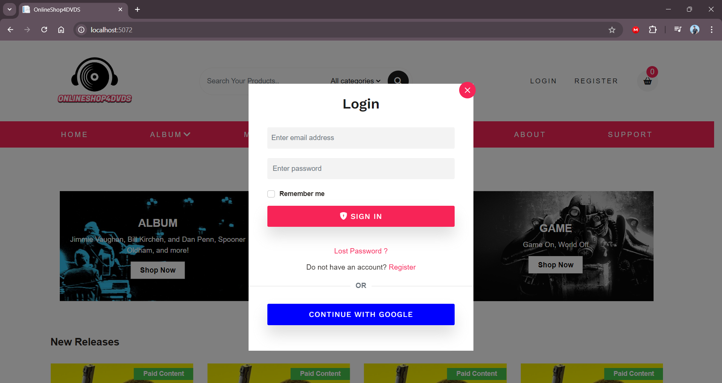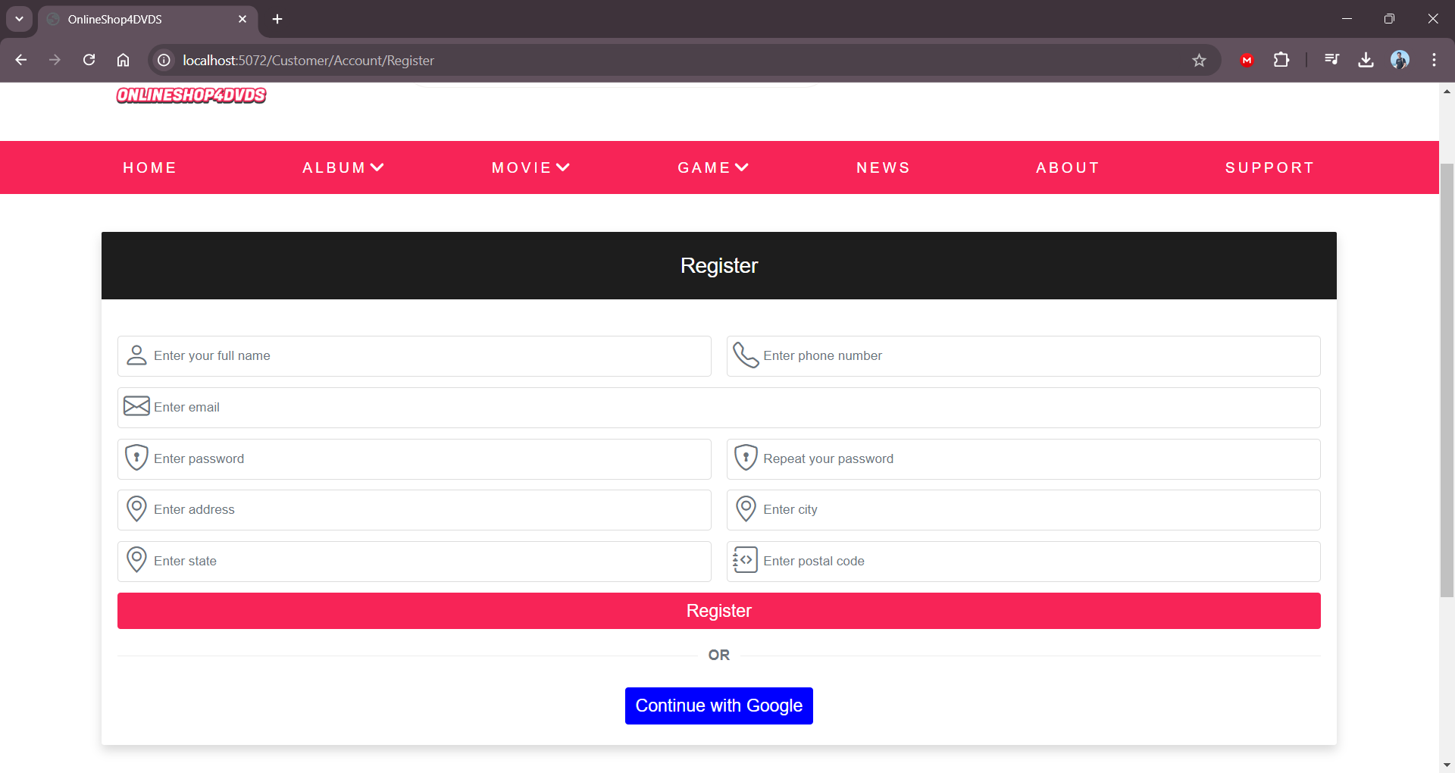

Code:

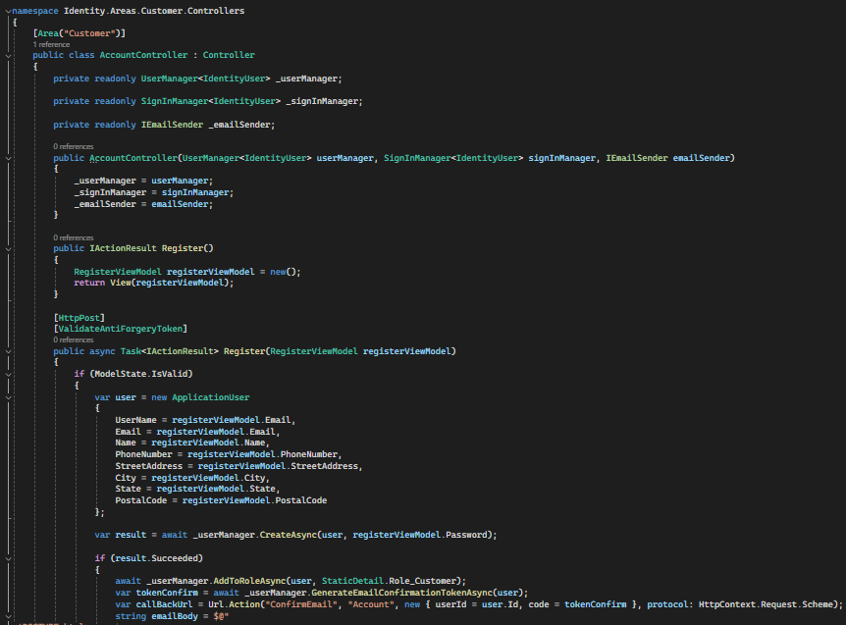

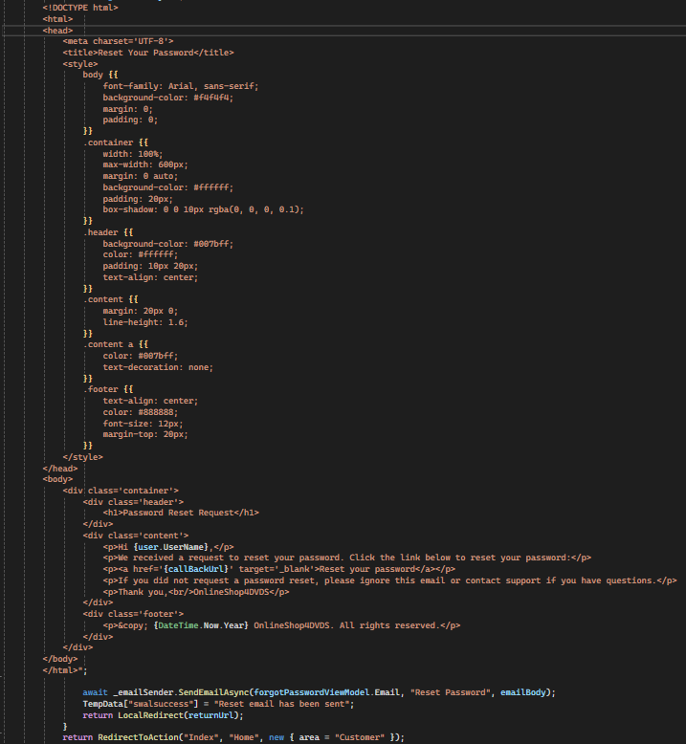

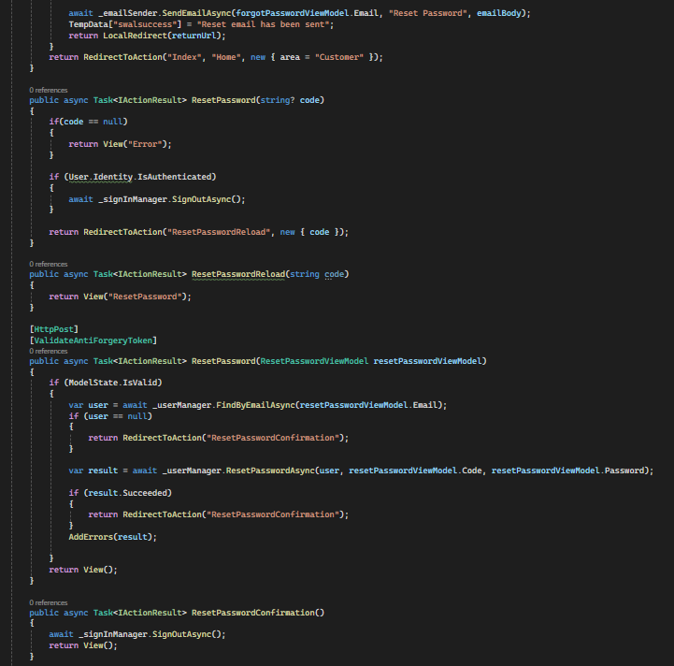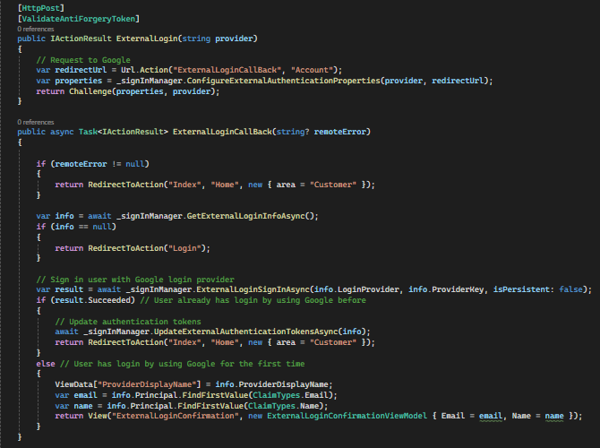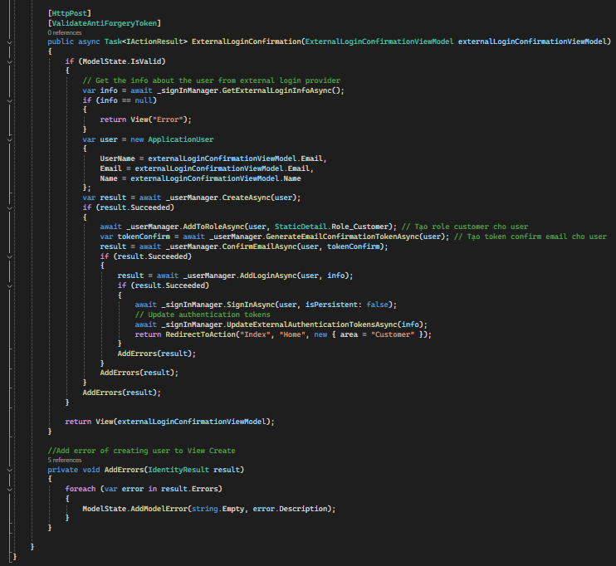

#### Authorized

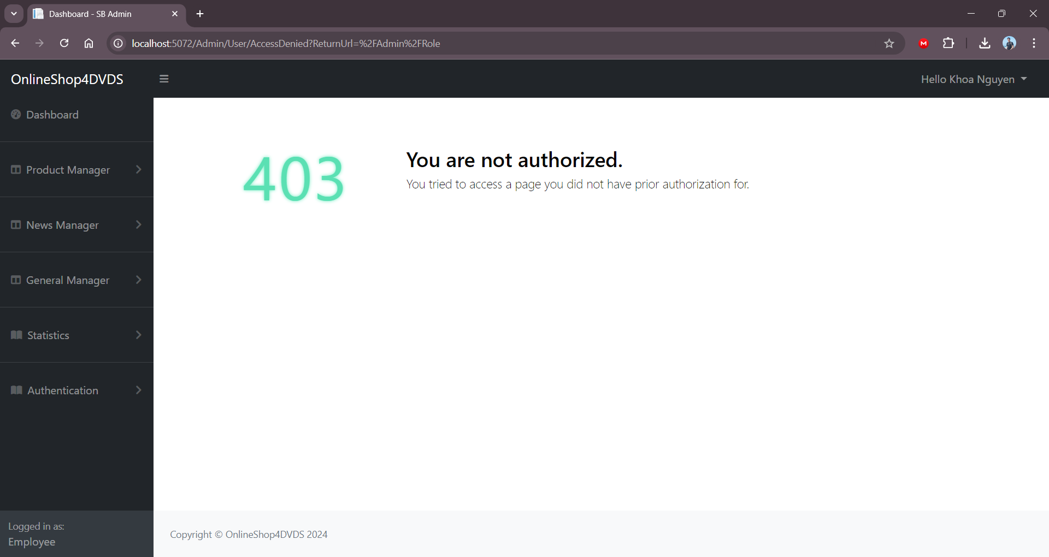

## Dashboard

### User management

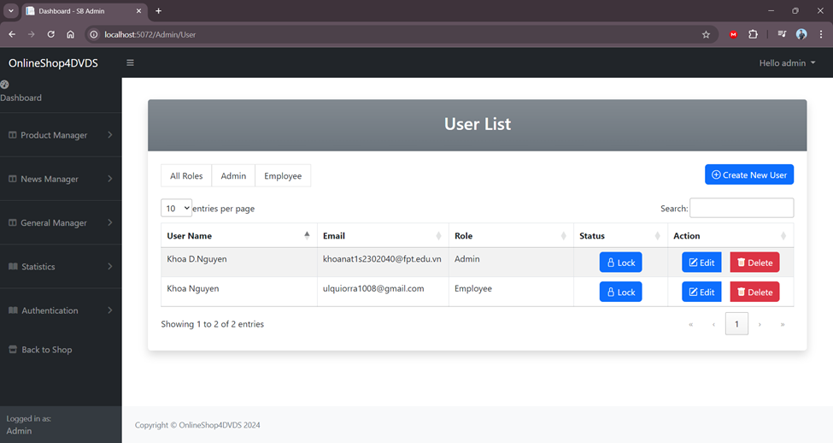

### Customer management

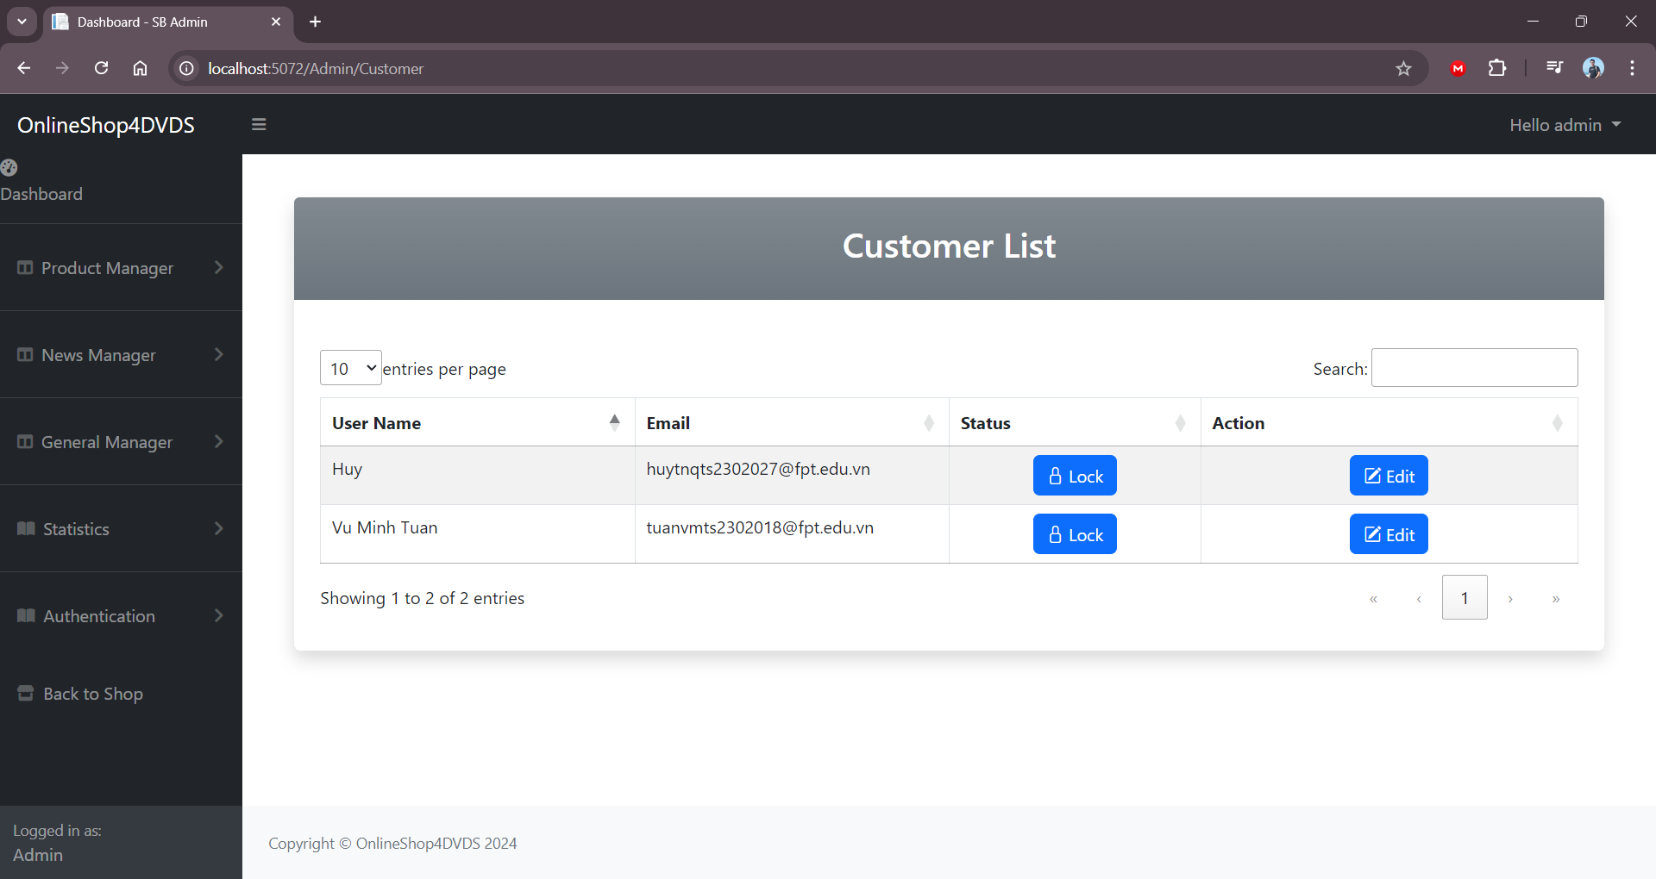

Customer can edit their password in the Account manager

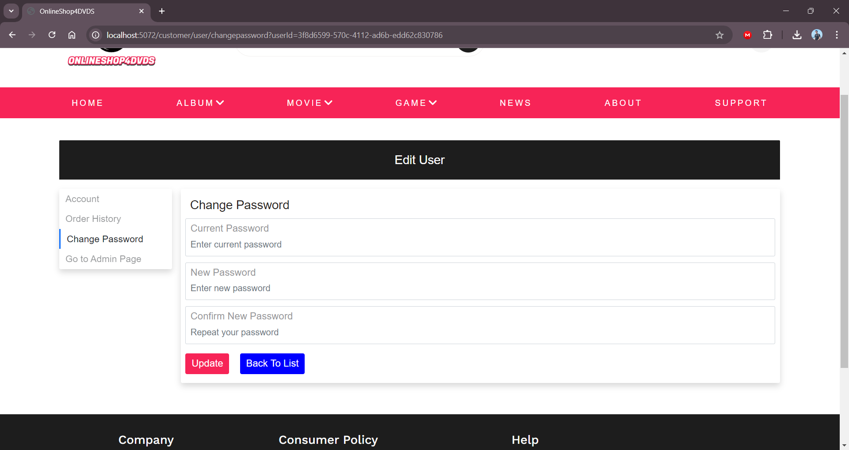

Code:

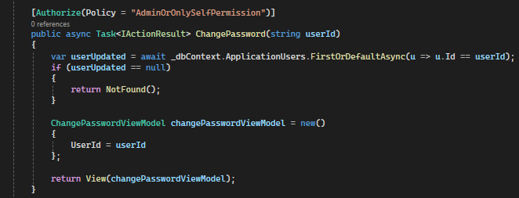

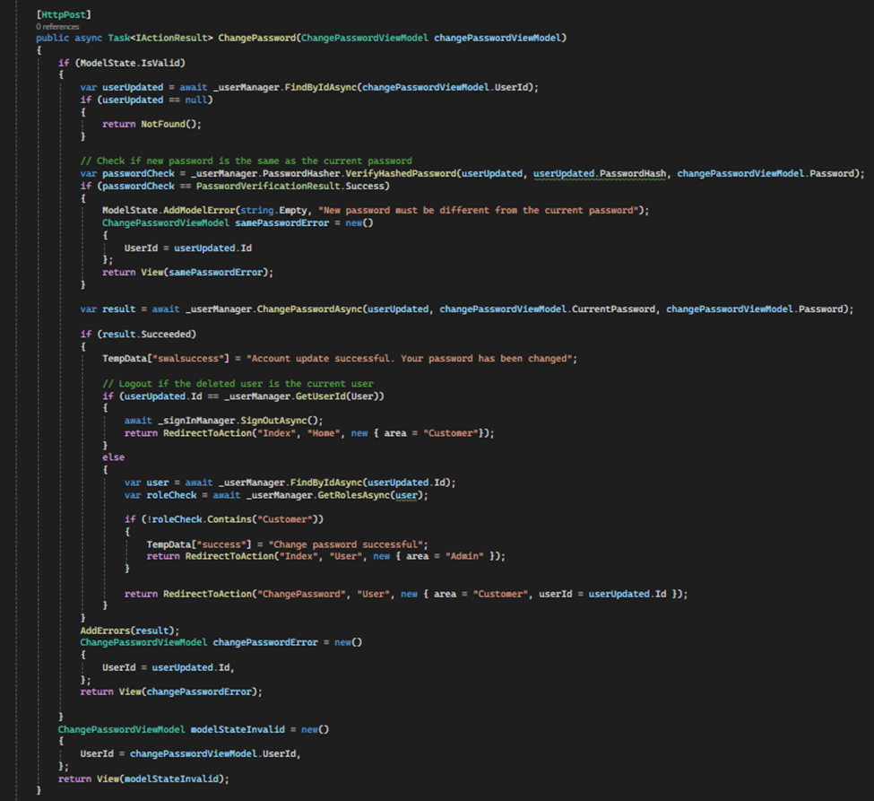

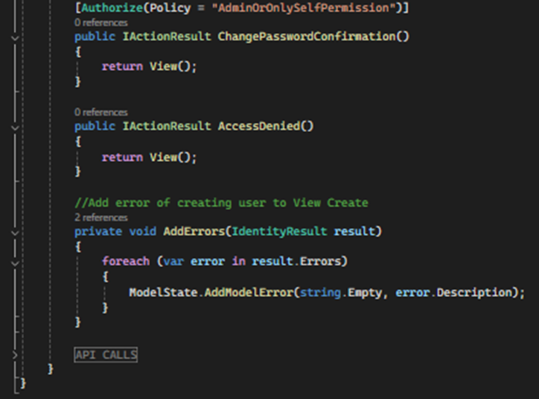

**TASK SHEET REVIEW 3**

|  |  |  |  |  |  |  |
| --- | --- | --- | --- | --- | --- | --- |
| **Project Ref. No.:** **eP/Advertisement** **Portal Management** **System/01** | | **Activity Plan** **Prepared** **By:** | **Date of Preparation of Activity Plan:** | | | |
| **Sr.No.** | **Task** | **Actual Start** **Date** | **Actual** **Days** | **Team** **Mate** **Names** | **Status** |
| 1 | User – login/logout | All Members | 07/12/2024 | 2 | Tuan | Completed |
| 2 | Admin - authorized | 07/12/2024 | 2 | Completed |
| 3 | CRUD User | 07/12/2024 | 1 | Completed |
| 4 | Layout | 07/12/2024 | 2 | Completed |
| 5 | CRUD Feedback | 07/12/2024 | 1 | Completed |
| 6 | CRUD Cart | 07/12/2024 | 2 | Hung | Completed |
| 7 | Payment | 07/12/2024 | 4 | Completed |
| 8 | CRUD Promotion | 07/12/2024 | 2 | Khoa | Completed |
| 9 | CRUD News | 07/12/2024 | 1 | Completed |
| 10 | CRUD Album | 07/12/2024 | 2 | Completed |
| 11 | Data Prep | 07/12/2024 | 1 | Completed |
| 12 | CRUD Game/Music | 07/12/2024 | 3 | Nhung | Completed |
| 13 | Stats/Chart | 07/12/2024 | 1 | Huy | Completed |
| 14 | CRUD Review | 07/12/2024 | 1 | Completed |
| 15 | CRUD Order | 07/12/2024 | 1 | Completed |

|  |  |
| --- | --- |
| **Date: 08/09/2024** | |
| **Signature of Instructor:**  **MR. LE TUAN XUYEN** | **Signature of Team Leader:**  **VU MINH TUAN** |